**Agents**

**Introduction**

In this report, I will explain how works the code that I did about agents in the python library sc2py written for SteemConnect2. Also, I will explain in more detail the strategy I used and the main parts of the code.

**Development**

The first thing to mention is that I relied on the tutorial provided in class, once I completed the tutorial, I started to design my own strategy and the decisions that my agent will make in a certain situation.

This is the map which I use for the project.

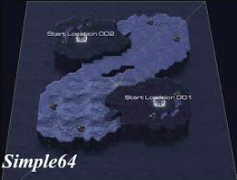 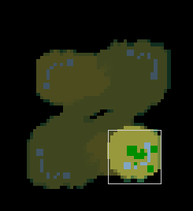

I will explain the different parts of my code from the tutorial. Basically, the Step function have all the changes that I made. Firstly, I define some variables that I will use along the code.

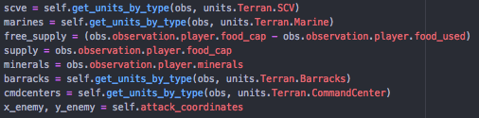

After this part of the code, comes the first sensor of the agent. Free supply is the variable which value is the subtraction between the whole supply of the agent minus the supply already in use, and if this is less than 1 it will build a Supply Depot. Why I put this at the beginning? Because the first thing that I want that my agent does, especially when my army is attacking the enemy, is verify this in order to create more marines to send them to attack. I define some ranges to build the Supply Depots, that ranges are at the back of the Command Center, close to the border of the screen in order to leave space in front of the Command Center to build the Barracks. Of course, before to build a Supply Depot, my agent verifies if there is a SCV selected, if not it select one.

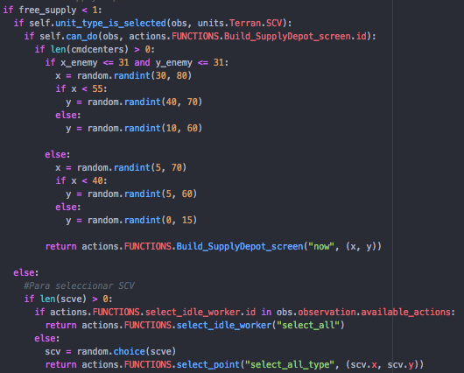

The next code is maybe the main part of my strategy. As you can see in the first part, where I define the variables x_enemy and y_enemy which took the attack coordinates that the tutorial code defines in the next lines of code.

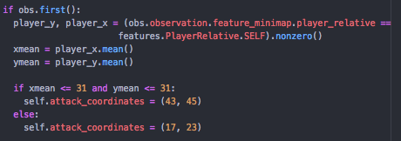

So, what I wanted to do is change the attack coordinates. If my army is already attacking the coordinate assigned before, the next time I create 15 or more marines I will change the attack coordinates to the other corner to see if the enemy have more buildings and when the next 15 marine’s were create the attack coordinates changed again and so on.

The way I did this is with the x_enemy and y_enemy variables. At the beginning, I assigned the values of the attack coordinates to the x_enemy and y_enemy, then I checked which corner was attacking to change to the other. So, if the x_enemy and y_enemy has (18, 45) coordinates in the map, the next coordinates will be (44, 45) and I assigned to “self.attack_coordinates”, then I will change again to (18, 45). The same thing happened when the attack coordinates are in the opposite side. From (18, 23) change to (44, 45) and vice versa. So, when I check the x_enemy and y_enemy to make the change, I just change the “self.attack_coordinates” and but the action of attack will be with the x_enemy and y_enemy and the next execution of the fuction step the x_enemy and y_enemy will have the new values of the “self.attack_coordinates” and so on. You can notice that in my code I make a lot of changes: in one case change from the (18, 45) to (16,45), then to (17,45), (44, 45), (42, 45) and (43, 45). Why I did that? When I was testing, I notice that the step function mas executed a lot of times so fast, so when I send to attack the army, this part of the code was executed so many times until the last marine in the screen had gone. So, with this I reduce the possibility that the next attack coordinates were the same as the last one and it never change.

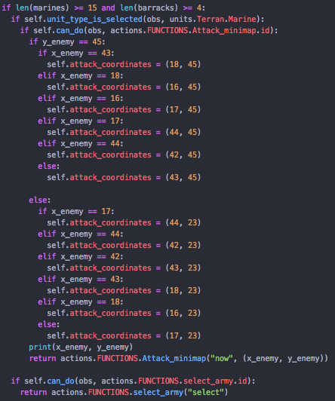

The next part, is to create the marine’s, so if there are less than 15 marines in the screen and more or equal to 4 Barracks I will create more marine’s. Also before of create more marines, there have to be selected one Barrack.

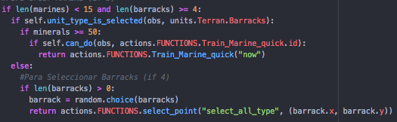

The I checked if there are less than 4 Barracks and more than 150 minerals in order to build another one. If this happened I verify if there is more than 15 SCVs and if there is one selected to build one, if not I select a SCV.

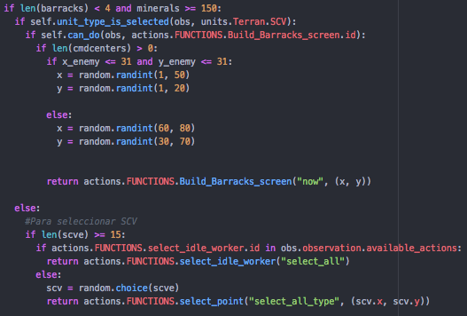

Then, I verify if there are less of 15 SCV and at least 1 Command Center to create more SCVs. As in the other actions, I verify if the Command Center is selected.

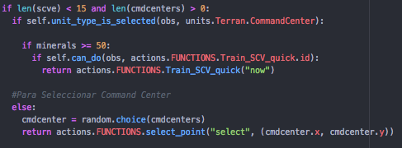

Finally, I just checked if there is not one Command Center, I build one and, of course, verify if there is on SCV selected.

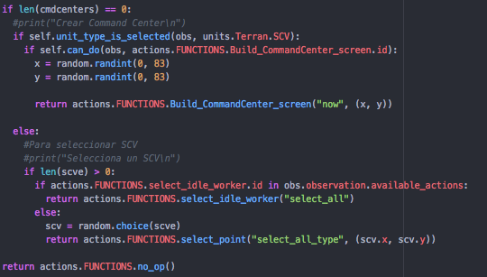

One thing to add, every time I have to select a SCV, I always try to select one SCV that is not working, if every SCV is doing something, I select a random one.

**Conclusion**

That is how my Agent works, I try several times in Cheat Insane and it wins many times. This project was so perfect to understand the concepts and how the agents works and how to model one.